Google Cloud Generative AI Project Documentation
1.Introduction
• Project Title: Intelligent SQL Querying with LLMs using Gemini Pro
• Team Members:
- M. Ajay (Team Leader)
- A. Anitha
- U. Anjali
- Y. Arshiya
- C. Bhargavi
2.Project Overview
• Purpose:
The purpose of IntelliSQL is to make database querying more intelligent, efficient, and accessible by using cutting-edge Generative AI technologies.
Through the fusion of natural language processing and LLM-powered SQL generation, IntelliSQL enhances data accessibility, reduces technical barriers, and enables faster insights from databases.
Ultimately, this project contributes to:
- Reduced technical barrier for database access
- Improved data accessibility for non-technical users
- Enhanced productivity through instant query generation
- A sustainable step toward AI-powered enterprise tools

3.Architecture:
Project Structure:
├── app.py # Streamlit web application (main UI)
├── sql_agent.py # Core engine: NL → SQL → Execute → Answer
├── database_setup.py # Database creation and schema utilities
├── requirements.txt # Python dependencies
├── .env # API key configuration
└── README.md # Project documentation
Database Schema (Company Database):
- departments — Department info (id, name, location)
- employees — Employee details (id, name, email, hire_date, job_title)
- projects — Project tracking (id, name, dates, budget, status)
- salaries — Salary records (employee-linked)
- project_assignments — Many-to-many: employees ↔ projects
4. Setup Instructions
Prerequisites:
- Python 3.9 or higher
- Google Cloud account (for Gemini API access)
- Internet connection
Technical Skills:
- Basic Python programming
- Familiarity with Streamlit web framework
- Understanding of SQL and database concepts
Hardware/Software Requirements:
- Computer with Windows, macOS, or Linux
- Python installed
- Web browser (for dashboard access)
Data Requirements:
- Access to sample company database (SQLite)
- Database schema includes departments, employees, projects, salaries, project_assignments
Tools and Libraries:
- Streamlit
- Pandas
- SQLAlchemy
- python-dotenv
- Google Gemini Pro API
- SQLite Browser (for database inspection)
- Postman (for API testing)
Domain Knowledge:
- Database querying and management
- Data analytics
Other Requirements:
- API key for Google Gemini Pro (obtain from Google AI Studio)
- Environment variables configured in .env file

5. Running The Application
After setting up the required dependencies and environment variables, follow these steps to run the IntelliSQL application locally:
Frontend:
- Streamlit (for interactive web UI)
- HTML, CSS, JavaScript (used within Streamlit components for visualization)
Backend (app.py server):
- Python
- Streamlit
- Pandas
- SQLAlchemy

6.User Interface:

6.1 Output Screenshots
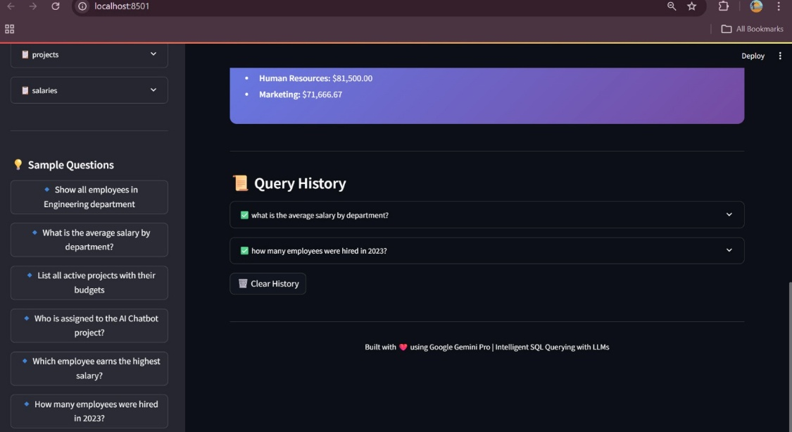

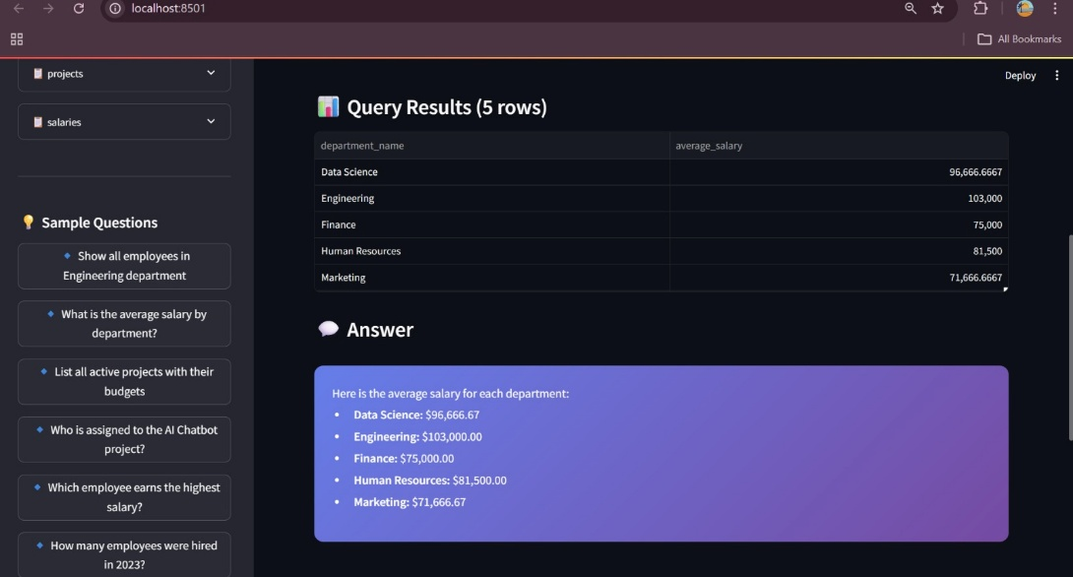

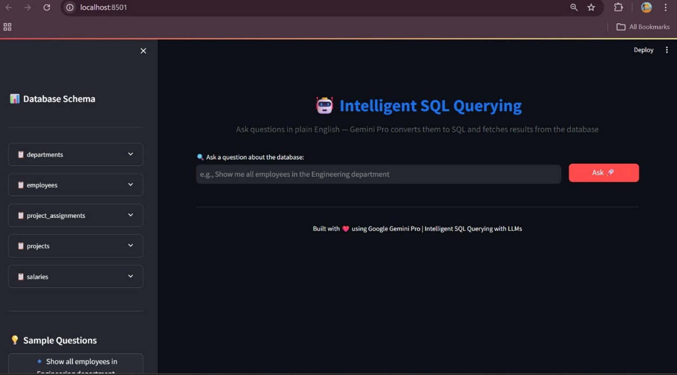
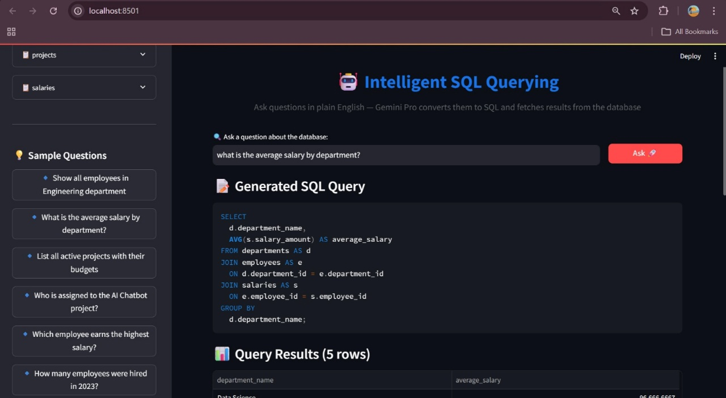

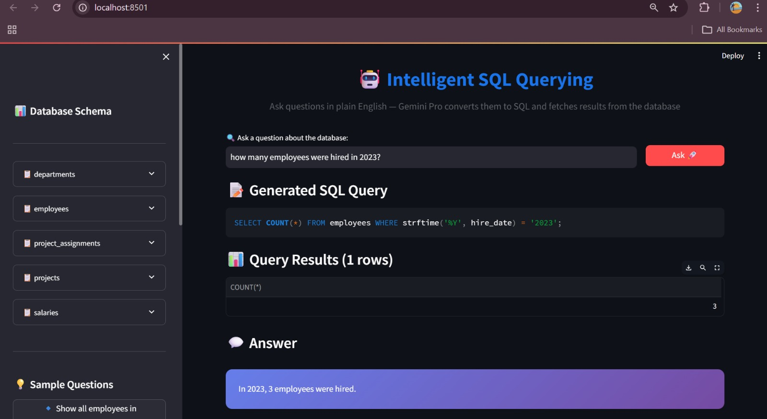

7. Testing
To ensure that all components of the IntelliSQL system—including the LLM-powered SQL generation, backend APIs, and Streamlit frontend—work correctly, efficiently, and reliably under various database scenarios before deployment.
Testing Strategy Overview:
- LLM Model Testing: Validate the accuracy and robustness of natural language to SQL conversion.
- Backend API Testing: Ensure APIs respond correctly, handle errors gracefully, and perform well under load.
- Frontend (Web Interface) Testing: Check UI responsiveness, usability, and correct data visualization.
- End-to-End Testing: Simulate real-world scenarios to verify the workflow from user query to SQL execution and result display.

8. Known Issues
- Occasional delays in API response due to network or LLM latency
- Limited database schema may affect query flexibility for complex questions
- No mobile application support currently (planned for future development)
- Basic UI design; lacks advanced user customization features
- Model performance may degrade for ambiguous or poorly structured queries

9. Future Enhancements
- Machine Learning & Model Enhancements (improve NL→SQL accuracy, add new features)
- Cloud Deployment (for scalability and reliability)
- Integration with enterprise databases (MySQL, PostgreSQL, etc.)
- Advanced AI Models (deep learning, multi-turn conversation context)
- User Personalization (customized query suggestions, saved queries, dashboards)

10. Conclusion
The IntelliSQL project demonstrates how natural language processing and large language models can be effectively combined to improve database accessibility. By providing accurate SQL generation, query execution, and result summarization, the system enables non-technical users to interact with databases efficiently. With its scalable architecture and user-friendly interface, IntelliSQL lays the foundation for smarter, more accessible data-driven applications. Future enhancements will further expand its capabilities, making it a valuable tool for business intelligence and enterprise data management.

